https://jomon-japan.jp/en/learn/jomon-culture
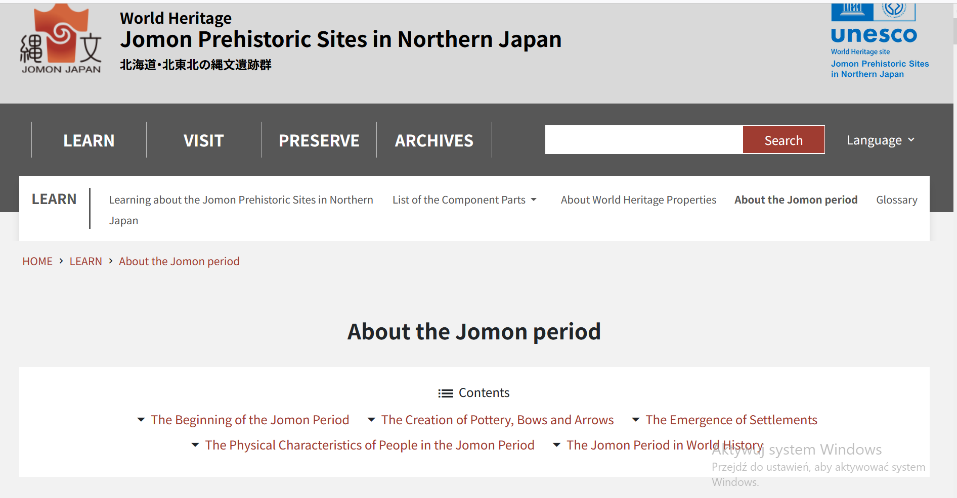

https://pl.khanacademy.org/humanities/art-asia/art-japan/japanese-art/a/a-brief-history-of-the-arts-of-japan-the-jomon-to-heian-periods
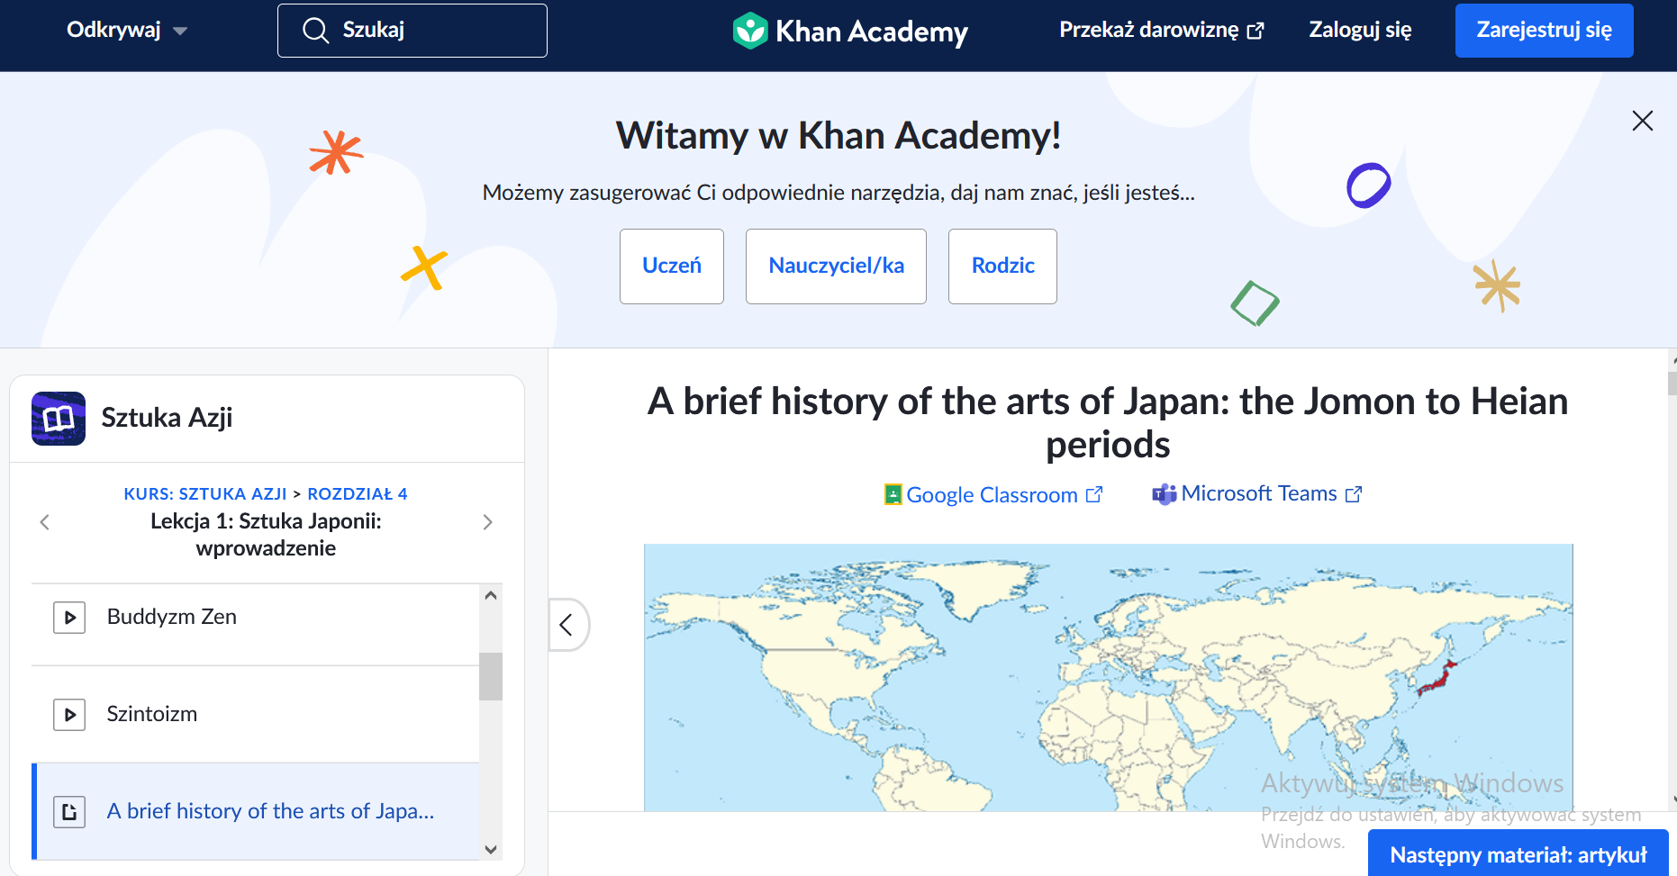

https://en.wikipedia.org/wiki/J%C5%8Dmon_period
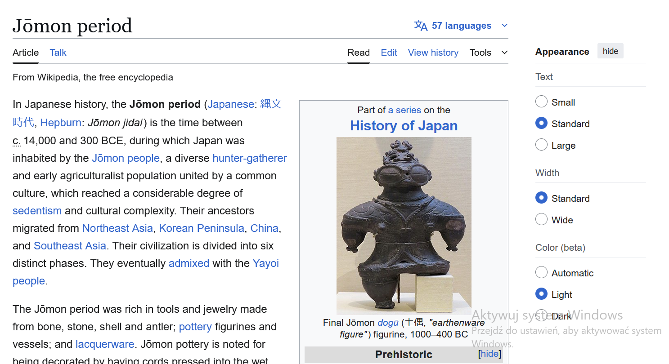

https://en.wikipedia.org/wiki/History_of_Japan
