<https://en.wikipedia.org/wiki/Shinise>

<http://www.spirit-of-shinise.jp/e/idea/>

# [http://www.spirit-of-shinise.jp/img/common/logo-e.png](http://www.spirit-of-shinise.jp/index-e.html)

[Japanese](http://www.spirit-of-shinise.jp/index.html)

## Spirit of Shinise is a force that lasts forever and forms the social capital.

Aspects that protect the goodwill of a *shinise* (established and long standing company) are the continuous flow of tradition and innovation, philosophy of foundation and perseverance in succession, and long-term employment and contribution to society, namely, a force that lasts forever. The concept of modern *shinise* differs not by facts such as whether it is listed on the stock market or owned by the founding family. It depends on how the company is viewed; for its liquidation value or as an everlasting body.

The philosophy of the Spirit of SHINISE [∫inisé] is to formulate a *shinise* spirit that can be the social capital (social infrastructure and bond between people) of the 22nd and 23rd century by stating a perpetual business body as the Spirit of SHINISE [∫inisé] which, as a public institution of society, pursues sound and long-lasting prosperity. Furthermore, our philosophy includes learning the fundamental nature of the spirit of *shinise* to add new values to the conventional view of *shinise*. This can be achieved by taking a path different from prevailing corporate recognition that puts emphasis on being listed on the stock market, not being owned by the founding family and the liquidation value of the company.

The spirit of *shinise* is a force that lasts forever and forms the social capital. The target of this inauguration meeting is to jointly implement ways to globalise the spirit of *shinise* (globalised *NOREN* [goodwill]) that developed regionally if globalisation can be defined as regionalisation accompanied with grand design.

The purpose of the Spirit of SHINISE [∫inisé] covers four aspects: (1) as a sound company resides in a sound society, establish a company that can last a hundred years in a sound society by paying attention to not just the year of establishment but also the years a century ahead, (2) basic principles shall be the real guidance for management and study the fundamental nature of the spirit of *shinise* that creates tradition through the continuity of innovation, (3) maximise customer satisfaction by ensuring great employee satisfaction, and (4) as the responsibility of the country that has the most number of *shinises* in the world, convey the *shinise*’s perspective of the world and the moral value that supports it to the people all around the world.

Note: The origin of the word ‘*shinise*’ comes from Zeami who wrote ‘…to make all these items that look very much the same (*shinise* in Japanese)’ (The Flowering Spirit) and from Ihara Saikaku who wrote about ‘business that is handed down (*shinise* in Japanese)’ (Japanese Treasury of Ages), which both emphasised the importance of copying the way that predecessors have inculcated and implied about an essential nature or universal characteristics that are generated through the process of copying the work of the founder and passed on to the next generation. Modern Japanese well know that copying or *shinise* is the basic philosophy as well as the DNA of a company, which demonstrates the spirit of *shinise* before having the status of an established and long standing company.

* [HOME](http://www.spirit-of-shinise.jp/index-e.html) |
* [Contact](http://www.spirit-of-shinise.jp/e/contact/index.html) |
* [Links](http://www.spirit-of-shinise.jp/e/link/index.html) |
* [Site Map](http://www.spirit-of-shinise.jp/e/sitemap/index.html)

Copyright 2009 Spirit of SHINISE All Rights Reserved.

<https://www.gardedesignmagazine.com/trendnews-japans-shinise-en/>

# Japan’s Shinise: Bastions of Stability

[Trend](https://www.gardedesignmagazine.com/category/trend/) / 04/09/2024

In the realm of Japanese business, few entities command as much respect and admiration as the shinise, traditional companies with over 100 years of history. The country is also home to the oldest company in the world, a construction firm specializing in temples and shrines with a mind-boggling 1443 years of operation. These long-standing establishments have weathered the storms of time and emerged as pillars of stability in an ever-changing economic landscape. Often passed down through generations, they embody not just a legacy of commerce but also a testament to the resilience and adaptability of Japanese entrepreneurship. In a time where society seems like it’s starting to regain its footing, let’s delve into some of the reasons for the stability and success of the shinise.

##### **Embracing Tradition: The Heart of Shinise**

At the core of Japan’s shinise lies a profound respect for tradition. These companies have not just survived but thrived by adhering to time-honored practices and values passed down through generations. Whether it’s the meticulous craftsmanship of a Kyoto ceramics workshop or the time-tested recipes of a family-owned sake brewery in Hiroshima, shinise companies embrace their heritage as a source of strength and continuity.

##### **Resilience in Adversity: Weathering Challenges**

Throughout their long histories, shinise companies have faced numerous challenges – from wars and economic crises to natural disasters and pandemics. Yet, time and again, they have demonstrated a remarkable ability to adapt and survive. This resilience stems not just from their financial strength but also from a deeply ingrained ethos of perseverance, innovation, and commitment to their employees, communities, and craft.

##### **Innovative Succession Strategies: Passing the Torch**

In cases where there are no blood-related heirs to inherit the family business, some shinise have adopted innovative strategies. They may seek out talented individuals from within the company or even outside it, who embody the values and ethos of the shinise, to carry on its legacy. This open-minded approach to succession ensures that the company’s traditions and culture can endure, regardless of familial lineage.

##### **Commitment to Craft: Steadfastness Amidst Change**

Furthermore, shinise companies are known for their unwavering dedication to their craft or product. Unlike modern businesses that may pivot quickly in response to market trends, shinise tend to stay true to their core offerings. This steadfast commitment to quality and tradition not only reinforces their brand identity but also fosters long-term customer loyalty.

Looking ahead, as Japan’s economy continues to evolve in the 21st century, the role of shinise companies remains as crucial as ever. Their ability to blend tradition with innovation, customer trust with global expansion, and resilience with adaptability will be key to navigating the challenges of an increasingly interconnected and competitive world. Japan’s shinise are not relics of the past; they are beacons of stability and strength, guiding the way forward for generations to come.

Post navigation

[← Previous Post](https://www.gardedesignmagazine.com/event-tabiico-photo-contest-2024-en/)

<https://www.japanhousela.com/articles/business-longevity/>

What makes a business successful? In some cultures, some common answers might be exponential profits or worldwide expansion. In Japan, however, there’s another key metric of success: longevity. Japan is home to the world’s oldest companies; according to Research Institute for the Centennial Management, over 52,000 companies in Japan are at least a century old, many with histories spanning multiple centuries. Known as shinise (which translates literally to “old shop”), these firms have weathered natural disasters, wars, pandemics and more, guided by certain values and by a careful balancing of tradition and innovation.

Long a point of national pride, Japan’s shinise are now becoming a source of global inspiration, with many international publications profiling these historical businesses with curiosity and admiration (such as a [New York Times profile](https://www.nytimes.com/2020/12/02/business/japan-old-companies.html) on the thousand-year-old Kyoto shop, Ichimonjiya Wasuke). In June 2021, JAPAN HOUSE Los Angeles launched a webinar series exploring the secrets to such long-term business sustainability; the second webinar is scheduled for September 2021. ([Click here for the event page](https://www.japanhousela.com/happenings/events/).) What has enabled the shinise to not just survive, but thrive, over such long time periods and through countless upheavals? And what can businesses around the world learn at a time when sustainability is more critical than ever?

It’s true that long-lasting companies can be found in other countries — Germany, for instance, has some breweries and wineries that date back to the 11th century — but as shown in a [study done by the Bank of Korea in 2008](https://www.bbc.com/worklife/article/20200211-why-are-so-many-old-companies-in-japan) surveying 41 countries, over 56% of companies older than 200 years are in Japan. The type of companies that reach shinise status range across several categories, but most trade in goods that are central to daily life (like food and beverage), traditional crafts or kogei (like metal and papercraft), or objects with deep cultural resonance (such as religious goods). A few, however, may be surprising — such as Nintendo. Today known for its videogames like Super Mario Brothers and the multimedia empire Pokémon, the company began in 1889 in Kyoto making playing cards. Like Nintendo, another shinise that expanded far beyond its humble origins is Kikkoman, the soy sauce manufacturer that was officially founded in 1917 but whose founders had already been producing soy sauce for 300 years. While these examples are now large global companies, the majority of shinise are family-owned and have stayed smaller in size — and even Kikkoman’s Executive Corporate Officer Osamu Mogi (a special guest in the inaugural webinar) is a descendent of one of the eight founding families of the company. A webinar held in September 2021 featured the CEO of Yamamotoyama U.S.A., a respected tea company that has operated a shop in the same location in Tokyo for more than 330 years. Though it has expanded its operations overseas, it remains family-owned. ([Watch video here](https://www.japanhousela.com/events/business-sustainability-series-yamamotoyama/).)

Keeping a business in the family allows shinise to pass down other key values from generation to generation. In some instances, family firms have even adopted heirs to ensure there will be a next generation to run things. But a company must have a strong foundation in the first place to create a legacy worth passing on.

The foundations of shinise are forged through perspectives and practices that differ from the focus on growth found in many contemporary global companies. One bedrock principle is wanting to protect the brand’s good name — so gaining and keeping the trust and loyalty of customers is paramount. This impulse also leads to slower and more incremental change, and to deprioritizing short-term profits in favor of long-term sustainability. For instance, a hundred-year-old tea shop might decide against a potentially profitable practice of also offering cakes if this action would risk impacting the quality and consistency of their customer service and alienating their most loyal tea customers.

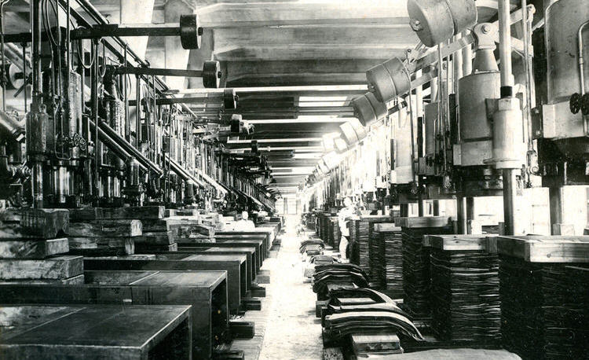

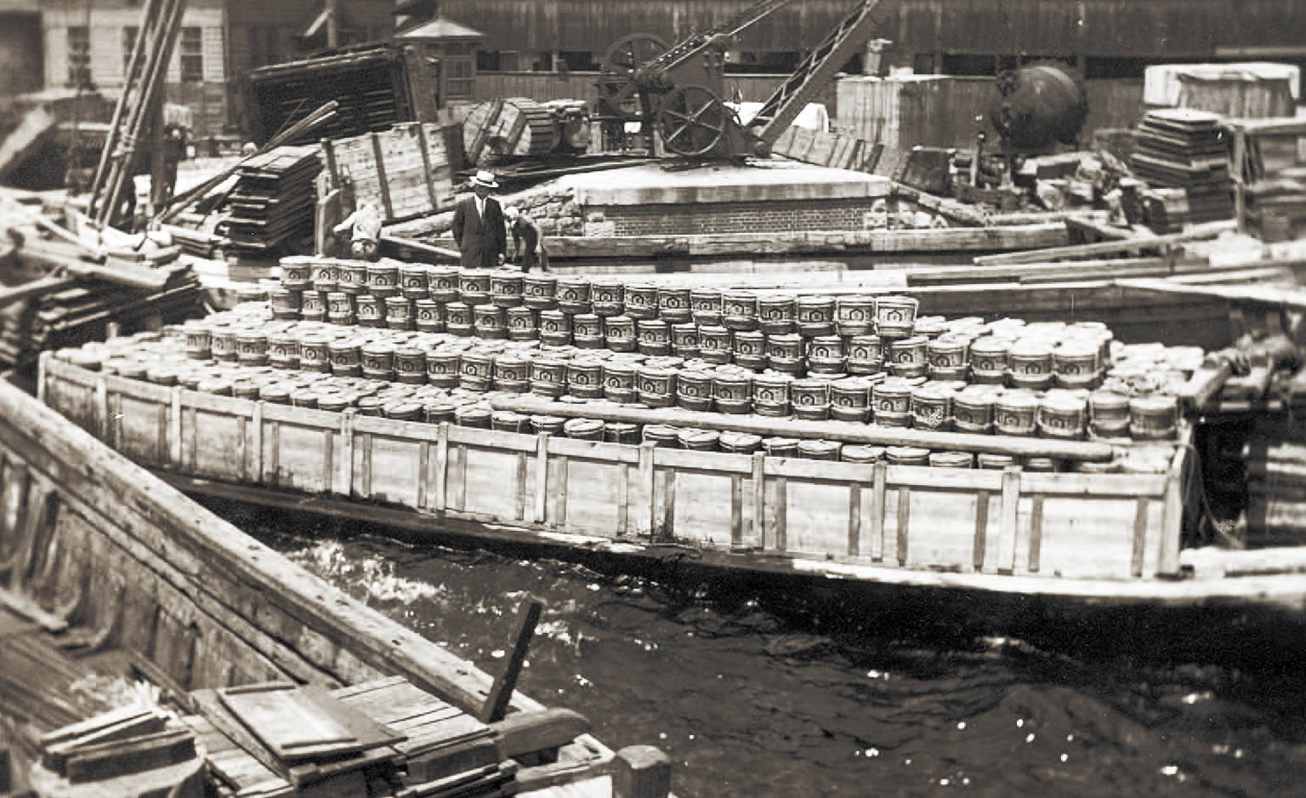

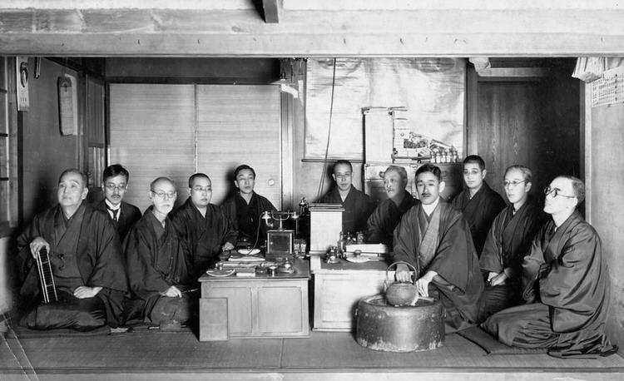









• • • Courtesy of Kikkoman U.S.A.

As well as considering the wishes of their customers, shinise also try to carefully balance their connection to their competitors, and their industry at large. As shared in the [first Business Longevity webinar](https://www.japanhousela.com/events/the-secret-of-sustainability-in-business/), Kikkoman’s ECO Mr. Mogi described how during World War II, there was a shortage of soy beans and other raw materials that led other soy sauce producers to experiment with “chemical” additives in their product. Kikkoman had invented a new method to continue traditional fermentation in a more efficient way — but instead of guarding this secret and taking 100% of the market share, they released this technique to their competitors to stabilize the soy sauce industry (and prevent a feared “race to the bottom” of poor quality). Their vision was much larger than their own company; it was to ensure the quality of an essential household staple, and to understand their own place in the fabric of Japanese society.

Throughout the history of shinise, we see examples of how the company’s good name, relationship with their community, and ability to survive even on small profit margins with little or no annual growth, are seen as more important than revenue growth or market expansion. These companies provide a contrast to many contemporary corporations which are often balancing the needs of investors to grow their investments and the hope of going public with an IPO. While shinise see themselves in an interconnected web with their founders, employees, customers, neighborhoods, raw materials of their products and the environment itself, many “young” companies around the world are not as focused on these concerns. However, especially at a time of climate crisis and the inequalities laid bare by the COVID-19 pandemic, more and more entrepreneurs are starting to look to the example of shinise which demonstrate healthy, sustainable ways to do business for good.

They can also take a final inspiration from the fact that products made by shinise are serve as status symbols — the strongest “branding” one could ask for. They are perhaps the ultimate luxury goods. While time is something money can’t buy, you can purchase a perfectly-crafted mochi from a thousand-year-old sweetshop like Kyoto’s Ichiwa — and it tastes delicious.

### Related Programs

#### Session 1 | Kikkoman U.S.A. An Introduction to Centuries-Old Businesses in Japan

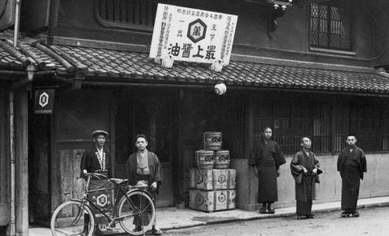

Photo provided by Kikkoman Corporation

[Watch Video](https://www.japanhousela.com/events/the-secret-of-sustainability-in-business/)

#### Session 2 | Yamamotoyama Looking into the Future with the Next Leader

<https://www.nakasendoway.com/omi-merchants/>

[Home](https://www.nakasendoway.com/) / [History](https://www.nakasendoway.com/category/history/) / Omi Merchants

# Omi Merchants

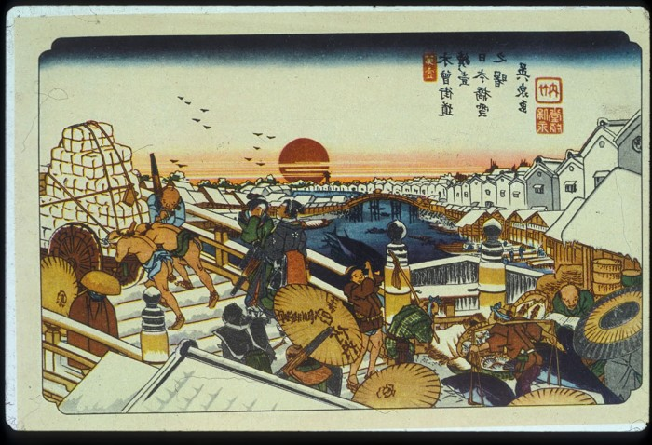

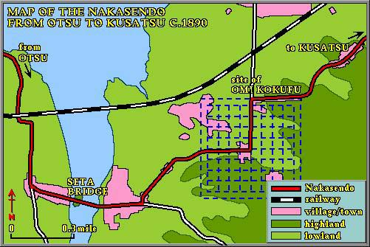  
Although the centers of commercial activities were located in the towns and large cities which grew up in the Edo period, the old province of Omi, the area south and east of Lake Biwa, played a large role. The Omi merchants became famous throughout Japan, and very rich too, through their base in jute and other commercial crops. Soon they were seen on a regular basis in large and small communities, trading in jute yarn, mosquito netting, home medicines and clothing. The Omi merchant, shouldering a pack larger than himself, became a stock figure on the Nakasendo highway, and a welcome visitor to homes starved of specialty goods from afar.

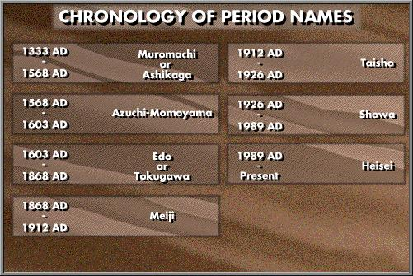

Merchants from rural areas like Omi came to fill a very important place in the commercial development of Edo period Japan. The large cities of the Warring States and early Edo periods drew their agricultural and manufactured supplies from the immediate rural areas surrounding them. As the decades passed, however, the cities grew so large that the surrounding areas could not provide all the demands of the cities. Edo in particular was a problem with its population reaching a million by the 1720s, and the district of Nihonbashi was one of the most overcrowded. It became necessary to draw on the production of distant towns and cities. Initially, much of this trade and commerce was funneled through Osaka and the merchants located in the large cities of Osaka, Kyoto and Edo monopolized and profited from the urban growth.

As time went on, the demands of the cities surpassed what the city merchants were able or willing to supply directly. Out in the provinces, such as [Omi](https://www.nakasendoway.com/?page_id=500), which were not too far away from the cities and from the highways, local entrepreneurs who had a bit of capital began to encourage peasant farmers to raise crops which would either be transported directly to the cities, or processed into a manufactured product and then transported. Through the efforts of the Omi merchants, large areas along the Nakasendo changed from subsistence agriculture to commercial agriculture which aimed to profit by raising and exporting its production.

Many of these merchants may have prospered by exploiting farmers in their own village or area. Various governments tried at one time or another to limit merchant activities in rural areas, but without success. One domain tried to ban rural merchants, but failed and then tried to limit the number of items which could be traded and the number of traders. This too failed and the number of legal peddlers doubled in less than fifty years. Soon peasant farmers were purchasing and selling not just necessities like farm tools, but luxuries like perfumes. Commerce, and prosperity, followed the Omi merchants as the years passed.

By the end of the Edo period, Omi merchants, and their cousins in other areas of Japan, had grown immensely wealthy. They were also uniquely situated because they had far-flung interests which brought them into contact with the political and economic changes of the last decades of the period. They often proved quick to anticipate the changes and take advantage of them and became influential in the modern period of capitalist development.

Category: [History](https://www.nakasendoway.com/category/history/), [Omi Merchants and Commerce](https://www.nakasendoway.com/category/history/omi-merchants-and-commerce/), [Post-towns](https://www.nakasendoway.com/category/post-towns-2/), [Themes](https://www.nakasendoway.com/category/themes/)

[Zapisz](https://www.pinterest.com/pin/create/button/?guid=AgKZ7Hj96cnY-1&url=https%3A%2F%2Fwww.nakasendoway.com%2Fomi-merchants%2F&media=https%3A%2F%2Fwww.nakasendoway.com%2Fwp-content%2Fuploads%2F2010%2F12%2F1-68-4.jpg&description=Omi%20Merchants)

#### From the glossary

* [Tokaido](https://www.nakasendoway.com/glossary/tokaido/)

The Eastern Sea Road or Tokaido runs from Kyoto to Edo close to the Pacific Ocean. Organized and administered by the central government in the 7th century, the road was usually easier to travel than the Nakasendo, except that its rivers were often more difficult to cross, and was the more important communication route during the Edo period. In the modern era, the Tokaido has seen heavy development as a transportation corridor, industrial belt and the most heavily populated area of Japan.

Nakasendo Way is brought to you by [Walk Japan Ltd.](https://www.walkjapan.com/), which operates the original tours to the Nakasendo Way.

<https://www.omi8.com/welcome-e/omi-merchants/>

# Omi Merchants

Omi merchants were traveling traders from the province of Omi (now Shiga Prefecture) who made a name for themselves throughout Japan between the sixteenth and nineteenth centuries. They established enterprises in cities and towns far from home and built up a strong reputation for their shrewd business sense, hard work, and spirit of fair dealing. They also contributed to the modernization of the Japanese economy during the Meiji era (1868–1912), and many of the businesses they started developed into corporations that still operate today. The wealth they accumulated is reflected in the fine houses that line the streets of historic Omihachiman.

The success of the Omi merchants was in part due to the geographical location of their base. Omi was close to both the political capital of Kyoto and the commercial hub of Osaka. The province was also on the route of both the Nakasendo and the Tokaido highways, the two main routes connecting Edo (now Tokyo) with Kyoto. Trading is thought to have been relatively widely practiced in Omi from the twelfth century onward, but the Omi merchants’ rise to prominence truly began in the sixteenth century with the free-trade policies initiated by the warlord Oda Nobunaga (1534–1582). Nobunaga had Azuchi Castle built as his center of power in Omi in 1576 and established a town below it. To encourage merchants to settle in Azuchi, he allowed them to operate independently of existing guilds and with a significant degree of freedom, under a system called rakuichi-rakuza (“free markets, open guilds”). In 1582, Oda Nobunaga was killed and his castle at Azuchi destroyed. However, another warlord, Toyotomi Hidetsugu (1568–1595), had a new castle built on nearby Hachimanyama in 1585 and established the town of Hachiman (now Omihachiman) in the area below the castle. He invited the Azuchi merchants to settle in Hachiman and continued Nobunaga’s free-trade policies.

Ten years later, Hidetsugu was dead and his castle abandoned, but the free-trade system had spread throughout Omi Province and facilitated a commercial boom. Omi merchants, having prospered during these years, began to expand their activities into other regions. Merchants from different areas of Omi traded in goods specific to their area and were active in different regions. Hachiman merchants typically dealt in mosquito nets, tatami surface matting, and hemp cloth products. They were among the first to open stores in Edo (now Tokyo), anticipating that city’s emergence as the de facto capital of Japan in the early 1600s after the establishment of the Tokugawa shogunate. They also took part in the development of Ezo (now Hokkaido). Before the Tokugawa shogunate forbade foreign travel, some Hachiman merchants journeyed as far as Siam (now Thailand) and Annam (Vietnam).

The classic image of an Omi merchant is of a peddler wearing a conical hat and a long cape, carrying goods on a long pole balanced on his shoulders. Omi merchants began their business by traveling this way across Japan, selling their goods and establishing a regular market for their most popular products, which they would then procure to order. When they had saved enough money, they would open a permanent store, and the most successful merchants were able to set up networks of stores in the major cities.

An important factor in the Omi merchants’ success was their strong business ethic. As outsiders in the regions where they peddled their goods, they were often treated with suspicion. They also had to deal with the general prejudice against merchants, who in Edo society were placed at the bottom of the social hierarchy because they did not produce anything tangible. To overcome these obstacles, they built trust with honest business practices and gained local acceptance by actively encouraging industries in the areas where they traded. The Omi merchants were firm believers in hard work, thrift, and fair dealing, and adhered to various principles that reflected their business philosophy. These principles were passed on from one generation to the next and were seen as fundamental for the lasting success of a family business. One was “save and strive” (shimatsu shite kibaru) expressing the merchants’ belief that long-term business success depends on making the most of what you have and working hard. One of the best-known principles of the Omi merchants is summarized in the expression sanpo yoshi or “benefit for all three parties.” This means any business deal should be good for the seller, good for the buyer, and good for society at large.

The Omi merchants’ ethos of contributing to society is reflected in the concept of “hidden virtue and good deeds” (intoku zenji). For the merchants, it was important to share wealth for the benefit of society without seeking praise and publicity for such works. Their contributions to society therefore took the form of funding for public works such as the construction of schools, roads, and bridges, and donations to shrines and temples.

<https://omi-syonin.com/about-omi-merchants/>

### Omi Merchants

Omi merchants were traveling traders from the province of Omi (now Shiga Prefecture) who made a name for themselves throughout Japan between the sixteenth and nineteenth centuries. They established enterprises in cities and towns far from home and built up a strong reputation for their shrewd business sense, hard work, and spirit of fair dealing. They also contributed to the modernization of the Japanese economy during the Meiji era (1868–1912), and many of the businesses they started developed into corporations that are still active today. The wealth they accumulated is reflected in the fine houses that line the streets of historic Omihachiman.

Merchants from different areas of Omi Province traded in goods specific to their area and were active in different regions. Hachiman merchants typically dealt in mosquito nets, tatami surface matting, and hemp cloth products. They were among the first to open stores in Edo (now Tokyo), anticipating that city’s emergence as the de facto capital of Japan in the early 1600s, and they also took part in the development of Ezo (Hokkaido). Some Hachiman merchants traveled as far as Siam (now Thailand) and Annam (Vietnam).

The Omi merchants were firm believers in diligence, thrift, and honest business practices. They developed this code of conduct in part to overcome deep-rooted suspicion of outsiders in general and merchants in particular. In Edo society, merchants were placed at the bottom of the social hierarchy because they did not produce anything tangible.

The Omi merchants adhered to various principles that reflected their philosophy. One was “save and strive” (shimatsu shite kibaru), in other words: long-term business success depends on making the most of what you have and working hard. Another principle was “benefit for all three parties” (sanpo yoshi), meaning that any business deal should be good for the seller, good for the buyer, and good for society at large.

A further principle was expressed in the motto “hidden virtue and good deeds” (intoku zenji). The Omi merchants believed their business should benefit society and that they should share their wealth without seeking praise or publicity for their actions. Their contributions to society therefore took the form of funding for public works such as the construction of schools, roads, and bridges.