Maria Peradzyńska – Filip

Maja Helbert

Marcin Adamski

Baroque Flute Sonatas

Baroque flute sonatas of George Philip Telemann and Jean Baptist de Boismortier for two and three flutes.

Stefan Banach
International Mathematical Center
31 May 2006

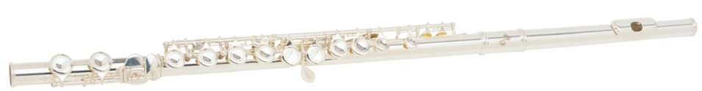
Maria Peradzyńska – Filip is a graduate of the Fryderyk Chopin Academy of Music where she studied flute. She is a prize-winner of many national and international competitions ( Pia, Duszniki Zdrój, and the "Tumbridge Wells International Young Artist’s Concert Competition"). She was twice awarded Boston University, Apple Hill Chamber Players and Stefan. Batory Foundation scholarships. Thanks to participation in master courses, she has had the opportunity of working with such artists as Jean Pierre Rampal, James Galway, Julius Baker and Marina Piccinini. Currently she teaches the flute class at the Karol Szymanowski Music School in Warsaw. Maja Helbert and Marcin Adamski – her students – are remarkably promising flautists of the young generation who have already won top prizes in competitions both in Poland and abroad, among others:

Young Musician’s Competition in Szczecinek
Maja Helbert, First Prize
Marcin Adamski, Third Prize

Spring Flute Festival, Sochaczew

Maja Helbert, First Prize

Marcin Adamski, Third Prize

Jeunesses Musicales Flute Competition
Maja Helbert, Fourth Prize

International Flute Competition, Chercasy, Ukraine
Maja Helbert, Second Prize

Stefania Woytowicz Flute Competition, Jaslo
Marcin Adamski - Fifth Prize

Marian Katarzynski Flute Competition, Sosnowiec
Marcin Adamski, Third Prize.

Maja was twice the recipient of the Minister of Culture and Arts Scholarship.

